1.   
   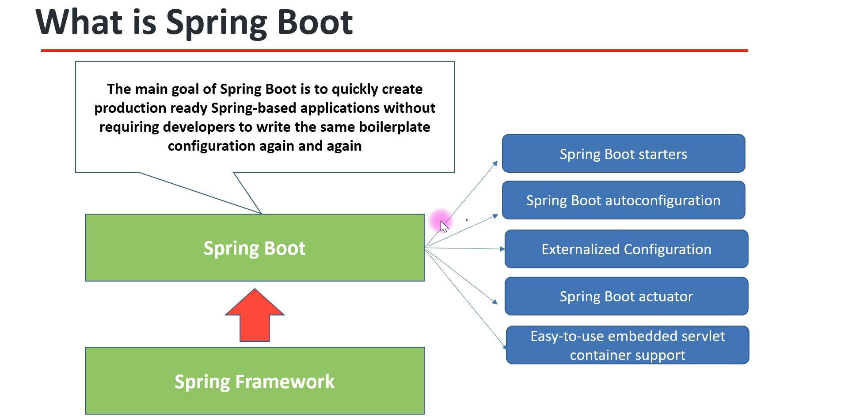
2. Features:
   1. **Spring Boot Starter**:
      1. Spring Boot offers many starter models to get me started fast with development such as   
         MVC, JPA, MongoDB, ElasticSearch etc.
      2. These starter dependencies are pre-configured with all the dependencies required.   
         So, we don’t have to search for dependency and that too compatible dependencies.
      3. **Example**:
         1. spring-boot-starter-data-jpa : It includes all the transitive dependencies such as Hibernate (by default as implementation for JPA).
         2. spring-boot-starter-web: It includes dependencies such as Spring MVC, Jackson, tomcat etc.
   2. **Spring Boot Autoconfiguration**:
      1. 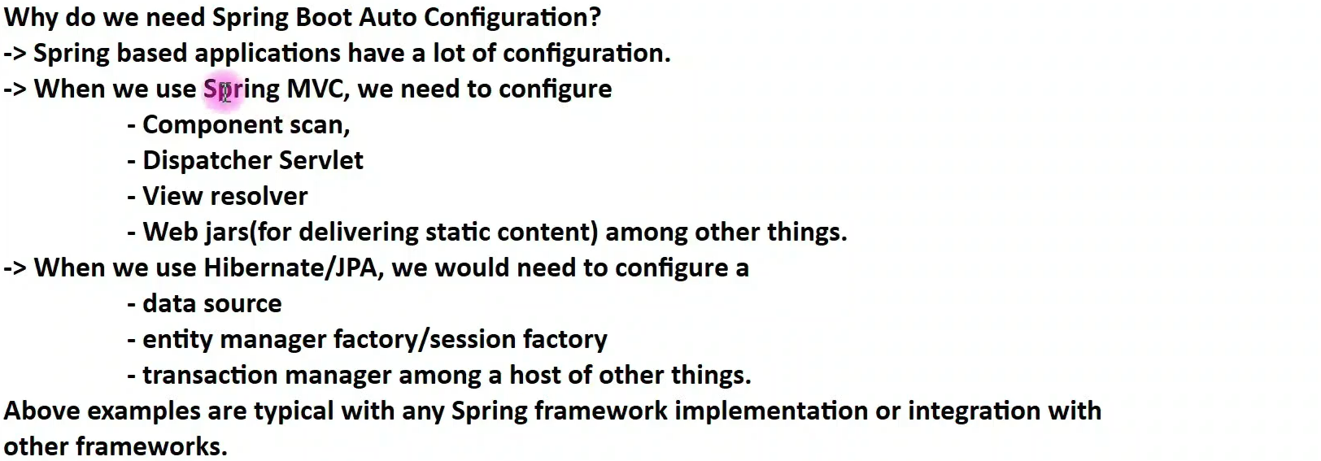
   3. **Externalized Configuration**:
      1. Useful when deploying Spring-Boot app in different environments (Dev, QA, UAT, Prod).
      2. @Configuration, @Value, @Profile
   4. **Spring Boot Actuator**:
      1. In Spring-Boot app, we configure a lot of details and we need then monitor those details.
      2. Actuator provides a lot of REST end-points and these endpoints are production-ready.  
         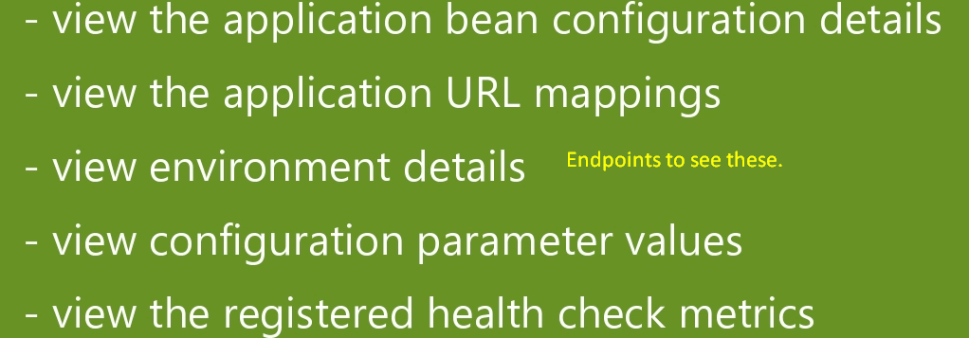
   5. Easy-To-Use Embedded Servlet Container Support:
      1. When we include spring-boot-starter-web dependency, it includes tomcat dependency as server and configure it automatically.